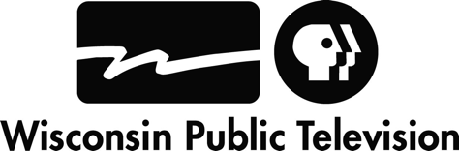
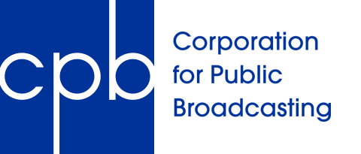
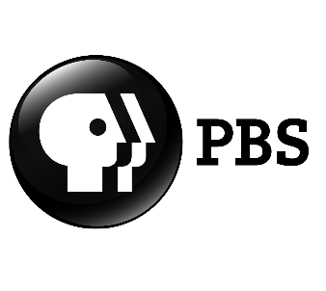

CPB, PBS Partner With Wisconsin Public Television
to Support Early Science and Literacy Learning in Westby and Cashton

Wisconsin Public Television Receives Ready To Learn Grant to Form Community Partnership to Help Underserved Children

(MADISON and WASHINGTON, D.C.) (DECEMBER 6, 2018) -- The Corporation for Public Broadcasting (CPB) and PBS today announced that public media station Wisconsin Public Television has been awarded $175,000 to work with community partners in Westby and Cashton to provide science and literacy resources for the youngest learners in underserved areas.
Wisconsin Public Television (WPT) is one of 14 public media stations nationwide to receive a Community Collaboratives for Early Learning and Media (CC-ELM) grant this year, joining 16 other public media stations doing similar work through a community engagement model to help the youngest learners in their communities. This effort is part of a five-year Ready To Learn grant awarded to CPB and PBS through the U.S. Department of Education’s Ready To Learn Initiative to advance new tools supporting personalized and adaptive content for children and parents, establish a network of community collaboratives and conduct efficacy research on the educational resources provided.
“WPT has been a critical part of the educational infrastructure of Wisconsin for more than 60 years, helping educators, parents and students prepare for academic success,” said Jon Miskowski, Director of Television at WPT. “This funding and opportunity will allow us to continue our focused work on preparing our youngest learners for success and will enable us to collaborate with two rural communities to help them develop critical programs and support networks for families and students.”
The grant will enable WPT to work closely with the communities and school districts in Westby and Cashton, Wis. to maximize the impact of new PBS KIDS science and literacy-based programming, mobile apps and digital games from trusted series “Ready Jet Go!” and “The Cat in the Hat Knows a Lot About That!” along with other media properties. Work will include professional development for educators and training for facilitators, parents and caregivers in best practices to engage families and children together in learning about scientific inquiry and literacy through digital media.

“The project represents a strong potential to better serve rural students, including our growing population of minority families, through integrated programs and services that meet their identified needs,” said Cashton School District Administrator Ryan Alderson, “Resources provided through effective collaboration around family engagement and technology, are aligned with our district mission, vision and values.”
“The opportunity to work with WPT to bring science and literacy education to our families would allow our students to experience big city resources within our limited rural means,” said Westby Elementary School Principal Bruce Peterson. “Parents in our district are hungry for this kind of outreach.”
“Public media’s high-quality children’s content has proven effective in helping our youngest learners make academic gains and experience social-emotional growth to get on the right track for school,” said Deb Sanchez, CPB’s Senior Vice President of Education and Children’s Content. “Through these grants supporting community collaborations, public media can provide engaging learning opportunities – for free, anytime and anywhere – for all children and families, especially those living in low-income communities.”
“Together with community partners, PBS stations play an integral role in helping our nation’s most underserved kids,” said Lesli Rotenberg, Chief Programming Executive and General Manager, Children's Media & Education, PBS. “We fully support the work of 14 additional stations sharing impactful resources with their local communities through these new grants. Their work builds on years of research demonstrating that PBS KIDS content is effective in helping children learn critical school readiness skills, with kids in low-income households often making the greatest gains.”

For the past two decades, the U.S. Department of Education’s Ready To Learn Television grant has funded the development of educational television and digital media targeted at preschool and early elementary school children and their families, especially those who live in low-income communities. CPB and PBS KIDS work with producers, researchers, local public media stations, and other partners to develop, distribute and evaluate PBS KIDS multiplatform content to engage children, families, and educators in learning experiences at home, in preschool and in out-of-school settings. Information on other stations receiving Community Collaboratives for Early Learning and Media (CC-ELM) grants can be found in the 2015-2020 grant announcement and 2016 press release.

Contact: Michael Harryman, Director of Communication
608-265-3855, michael.harryman@wpt.org
-END-

About Wisconsin Public Television (WPT)
WPT is a service of the Educational Communications Board and the Board of Regents of the University of Wisconsin-Madison.
Wisconsin Public Television is a place to grow through learning on WHA-TV, Madison; WPNE-TV, Green Bay; WHRM-TV, Wausau; WLEF-TV, Park Falls; WHLA-TV, La Crosse; and WHWC-TV, Menomonie-Eau Claire.
About CPB
The Corporation for Public Broadcasting (CPB), a private, nonprofit corporation created by Congress in 1967, is the steward of the federal government’s investment in public broadcasting. It helps support the operations of more than 1,500 locally owned and operated public television and radio stations nationwide. CPB is also the largest single source of funding for research, technology and program development for public radio, television and related online services. For more information, visit cpb.org, follow us on Twitter @CPBmedia, Facebook, and LinkedIn and subscribe for updates at cpb.org/subscribe.
About PBS KIDS
PBS KIDS, the number one educational media brand for kids, offers all children the opportunity to explore new ideas and new worlds through television, digital platforms and community-based programs. Kidscreen- and Webby-award winning pbskids.org provides engaging interactive content, including digital games and streaming video. PBS KIDS also offers mobile apps to help support young children’s learning. The PBS KIDS Video App is available on a variety of mobile devices and on platforms such as Roku, Apple TV, Amazon Fire TV, Android TV, Xbox One and Chromecast. For more information on specific PBS KIDS content supporting literacy, science, math and more, visit pbs.org/pressroom, or follow PBS KIDS on Twitter and Facebook.
About The Ready To Learn Initiative
The Ready To Learn Initiative is a cooperative agreement funded and managed by the U.S. Department of Education's Office of Innovation and Improvement. It supports the development of innovative educational television and digital media targeted at preschool and early elementary school children and their families. Its general goal is to promote early learning and school readiness, with a particular interest in reaching low-income children. In addition to creating television and other media products, the program supports activities intended to promote national distribution of the programming, effective educational uses of the programming, community-based outreach and research on educational effectiveness.
The contents of this release were developed under a grant from the Department of Education. However, those contents do not necessarily represent the policy of the Department of Education, and you should not assume endorsement by the Federal Government. The project is funded by a Ready To Learn grant (PR/AWARD No. U295A150003-18, CFDA No. 84.295A) provided by the Department of Education to the Corporation for Public Broadcasting.

